A03 Bridging Neuroscience and Artificial Intelligence
Ezra Bakatubia
ITAI 4374
Due 2/27/26

This report goes into the deep connection between the biology of the human brain and the design of modern artificial intelligence. While Ai is built on math and code, its fundamental structure artificial neural networks was directly inspired by how biological neurons talk to each other. By using to study neuron anatomy and brain hierarchy, we can see how things like "dendrites" became "inputs" and how the visual cortex inspired the layers of a CNN Model. Understanding these biological roots helps us see where Ai is going next and how
we can make machines more efficient and adaptable like the human mind.

Part One:
When we look at a biological neurons, we see a complex living cell. Even though Ai is digital, it tries to copy this setup.
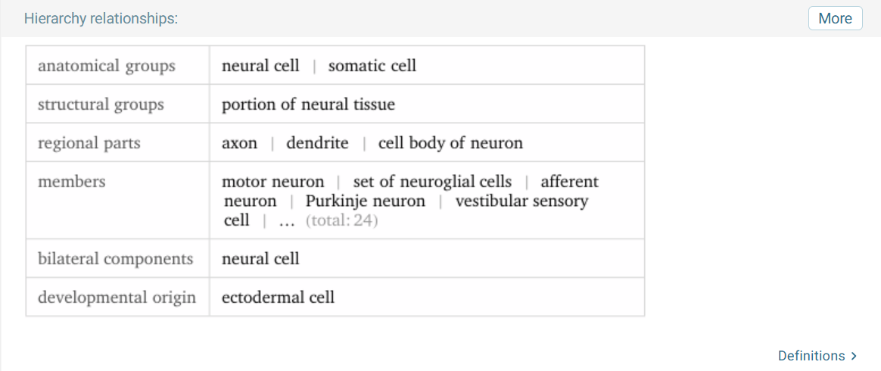
Wolfram Alpha output for 'human neuron anatomy.' The data identifies the axon, dendrite, and soma (cell body) as the primary regional parts of the neuron, providing the biological blueprint for artificial neural network layers.
The cell body or soma is like the processing unit in a computer because it decides if a signal is strong enough to pass on. Dendrites act like input connections that bring in information from other places. The axon is the long tail that serves as the output connection to send the message away. Finally, synapses are the gaps where signals get stronger or weaker, which is exactly what weights do in an artificial neural network.
Comparing Biological and Artificial Neurons
The main reason we built AI this way is because the human brain is the only proof we have that high level intelligence actually works. Early designers saw how neurons fire in a
chain and thought we could do the same with math.
The biggest difference is how they work. A brain is electrochemical and messy, using chemicals to change connections over time. Ai uses steady math and calculus. Biological neurons are also way more efficient. A human brain can learn to recognize a cat after seeing one twice, but an artificial model might need thousands of pictures to get it right. However, Ai has the advantage of speed. Digital signals move much faster than chemical ones, and Ai doesn't get tired or forget things the way humans do.
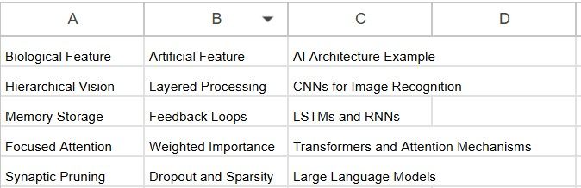

Part Two: Brain Architecture and AI Design
The human brain is organized in a hierarchy. Lower sections handle basic things like breathing, while the outer layer, the cerebral cortex, handles the smart stuff.
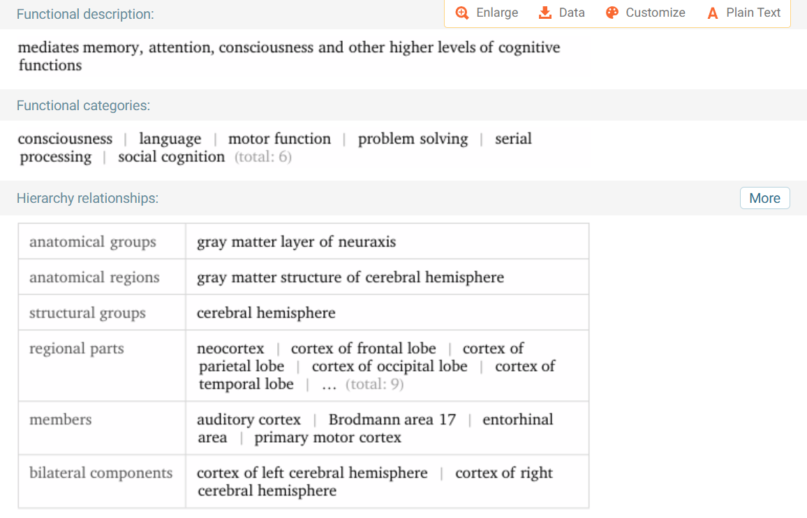
Wolfram Alpha structural hierarchy of the cerebral hemisphere. This data identifies the neocortex as a primary regional part, which functions as the biological blueprint for the hierarchical "smart" layers in advanced AI models like CNNs.

In AI, we see this same hierarchy. For example, a CNN works like our visual cortex. The first layers see simple lines, the middle layers see shapes, and the final layers see faces.
We also see parallels in memory. The hippocampus helps humans store long term memories, which is very similar to how Long short term memory networks use gates to decide what information to keep for later and what to throw away. Even the new "attention" mechanisms used in chatbots are just digital versions of how our brains filter out background noise to focus on one conversation.
The Amygdala and AI
The amygdala is the part of the brain that handles emotions and fear. While we don't want AI to be "moody," adding a version of emotion processing could actually help with risk assessment. If an AI has a "fear" response to bad data or risky patterns, it could stop itself before making a mistake. This would make AI decision making much safer because the system would have a built-in sense of caution rather than just following a line of code blindly.

Part 3: The Future
If we want to make better AI, we have to look at how the brain saves energy. Right now, training a massive AI model takes enough electricity to power a small town. The human brain runs on about 20 Watts, which is less than a dim lightbulb.
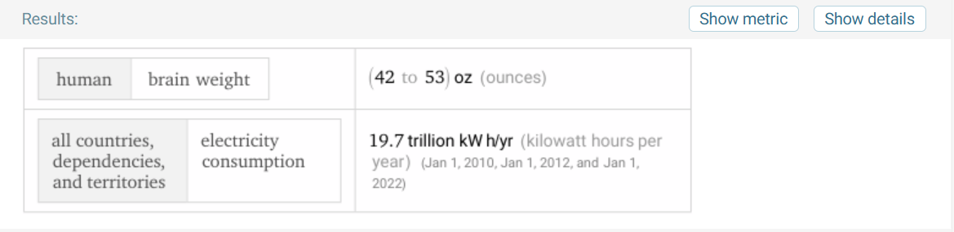
Wolfram Alpha data used to calculate the comparative energy efficiency between biological and artificial systems. While modern AI requires massive electricity, biological systems operate at significantly lower power benchmarks
By studying biological "spiking" neurons, which only fire when they have something important to say, we could create AI that uses much less power.
Another huge gap is generalization. A human can learn to drive a car and then use those same spatial skills to play a video game. AI usually has to be retrained from scratch for every new task. In the future, I think Ai will move toward "biomimetic" learning. This means the AI won't just look at data points, but will learn through curiosity and trial and error just like a child does. If we can figure out how the brain creates common sense we can move past simple pattern recognition and create machines that actually understand the world they are looking at.

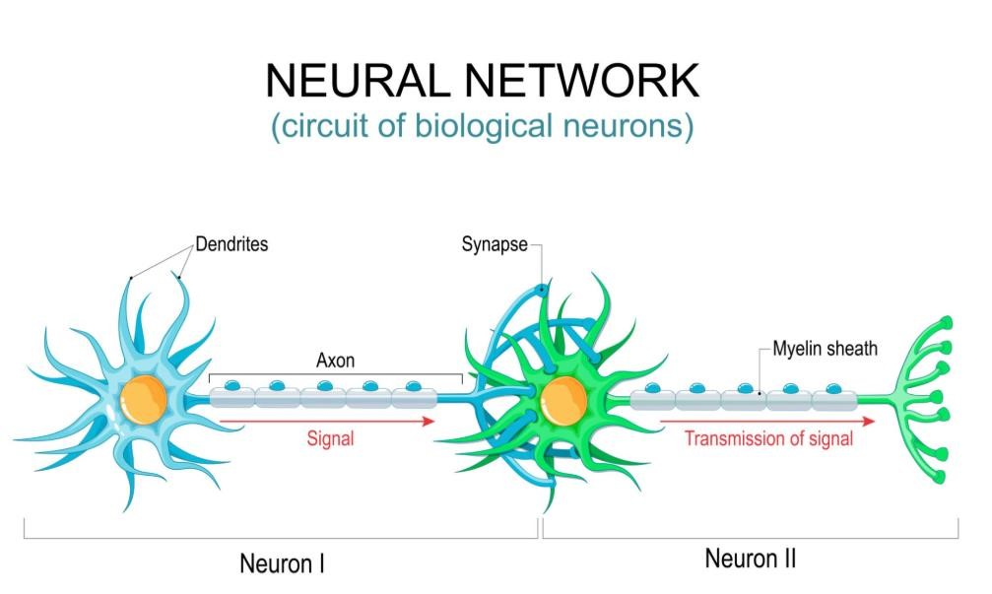
A circuit of biological neurons illustrating signal transmission. The dendrites serve as input terminals, axon acts as the transmission, synapse functions as the connection point where signal strength is modulated, like weights in models.

